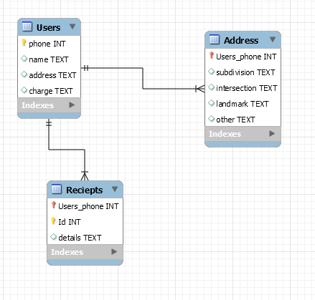

The ER Diagram above depicts the 3 databases of our Pizza program. The primary key of the Users table is the phone number, the phone number in our design is how everything is stored and looked up. The users table stores the Phone, Name, Address, and charges for the User. The Users Table connects to the other Two tables in the Database as a One to many relationship to address and to Receipts, as a User can order and have deliveries to more than one address, as well as have multiple receipts from different orders. All three databases are linked by the Users phone number.